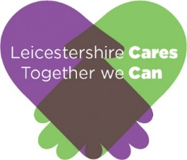Connect To Change:

Leicestershire Cares’ Annual Plan 2024-25

*“What I like about Leicestershire Cares is that lots of youth projects just focus on changing the young people but they support the young people to try and change the systems and structures that impact on the young people and the neighbourhoods and communities they live in” Community Worker Belgrave*

*Leicestershire cares is instrumental in supporting us and other stakeholder through meaningful dialogue. We appreciate their leadership in uniting community organisations. Young Youth worker*

*“It is an absolute pleasure to partner with Leicestershire Cares, you make it easy for the business community to engage with the community and young people” Sue Woollett, Social Value Manager, Stepnell*

*“Leicestershire Cares tirelessly for their cause, not scared to partner with and alongside others to accomplish what is needed for the young people and community groups they support. Their work on bringing smaller voluntary groups together to partner is a success that can only grow and be an example to others in how to work together and grow services that are often not recognised.” Steve Meadwell, Regional Manager (Midlands)for CSJ (national Policy think tank)*

*“LC is a local organisation who is leading the way in shaping how the NHS is working with young people to improve healthcare” Jacob Brown Children, Young People and Families Engagement Officer, NHS: Leicester, Leicestershire and Rutland Integrated Care Board*

*“"I found Leicestershire cares to be more of a supportive community rather than a typical service.... it also gave me a space to voice my personality and passions for my future" Care experienced young woman*

# Introduction

Leicestershire Cares is a vibrant and result orientated award-winning charity that has been operating successfully across Leicester city, Leicestershire and Rutland (LLR) since 2003. We are a creative, agile and resilient organisation that delivers change for young people and communities through our joined up approach to work.

# Vision, Mission and Goals

## Our vision

An inclusive and safe Leicester, Leicestershire and Rutland where nobody is left behind, and all children and young people are supported to reach their full potential.

## Our mission

We broker partnerships and create opportunities across Leicester, Leicestershire and Rutland that enable the business sector to understand community needs, contribute to the growth of inclusive, safe communities and to support and inspire children and young people in their transition to the workplace.

## Our values

**We believe in partnership.**We broker partnerships between business, local government, schools and community groups so they can share skills and knowledge to deliver lasting positive change for disadvantaged groups and individuals.

**We believe in the power of employee volunteering.**We believe that employee volunteering enables volunteers, community groups and individuals to develop skills and understanding and is a highly effective way of strengthening communities and increasing employee engagement.

**We focus on impact.**We focus on impact and ensuring the work we carry out delivers meaningful and lasting positive change.

**We are inspiring.**We inspire people and organisations to identify their aspirations and to reach their full potential by thinking creatively and testing innovative approaches.

**We are Inclusive.**We seek to learn from the rich cultural diversity of Leicester, Leicestershire and Rutland and to build cohesion across community groups and to remove barriers to people’s participation.

**We are committed to learning and development.**We continually review the community need and are agile enough to adapt and improve the services we offer to work in a mutually beneficial way with relevant organisations.

# The ongoing challenges

Our city and county continue to face many challenges which are exacerbated by poverty. Research by Loughborough university showed 40% of children in the city are living in poverty and many of these have at least one parent who is working. Within the county child poverty continues to hover around 10 to 20 percent, depending on the location. Alongside this Leicester city council has shared that it is preparing to declare itself bankrupt whilst also making cuts to vital services. The county and district councils are all making significant cuts to services which leads to a situation where an increase in poorer people goes hand in hand with cuts to the services they look to for support.

Following on from riots in Leicester East in the Autumn of 2022, which were seen to be linked to tensions between Muslim and Hindu communities, local politics has become strained. In the May elections, whilst nationally there was a big swing to labour in Leicester the Labour council lost 22 seats, with the conservatives winning 17 seats. In the county, the conservatives lost control of several district councils. Many in the community feel these results reflect people feeling disillusioned with local and national politics and not being able to see how those in power are going to help them.

In addition to these social issues and political challenges, the local economy and business sector is struggling.80% of businesses in Leicester are SME’s and the knock-on effects of Brexit, Covid 19 lockdown and energy price increases has hit them hard. So many are struggling to survive and talk about challenges in recruiting and retaining employees, hold ups in supply chains and increases in production costs pushing them to the brink.

*“I cannot recall a tougher time to be working in the community, everywhere I look there are cuts in services, a huge increase in poverty and families and young people in need, with nowhere to go for support they deserve” Community Leader Leicester East*

Our Power to Change approach to working with young people and communities is we believe well suited to dealing with the complex web of issues, these challenges present.

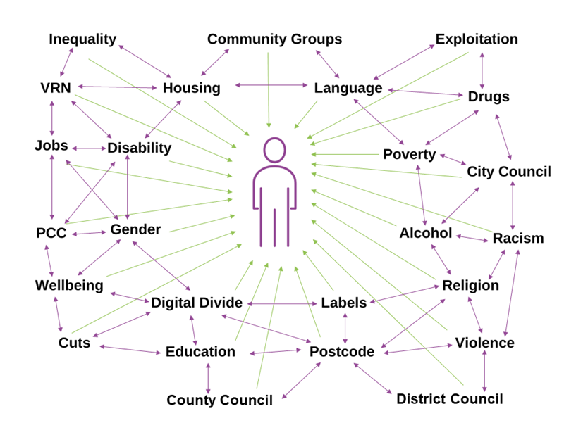

**Impact on young people: Complexity.** The place and context in which young people live has a significant impact on their life chances. They are affected by a range of overlapping and interlinked issues. The key point to highlight here is that there is not one neat, linear solution to a simple cause and effect, rather for most of the young people we work with, there is a complex web of issues that need to be addressed in an agile and creative way.

These complex issues often include having experience of and been emotionally scarred by the care system; physical and mental health issues; insecure or inappropriate housing; addictions; involvement in crime; lack of family support; having children taken into care; domestic abuse; debt and financial management issues; racism; immigration status; living in a deprived area; poor levels of basic education; and being unwilling or unable to get a job. For many of these young people, the impact of Covid 19 and economic issues caused by energy crisis and the war in Ukraine seemed to be just another hurdle and stress in their often chaotic and complex lives.

It is our strong belief based on reflecting on our practice, that to work effectively with these young people, we need to understand the complexity of their life situation and work with them to address these overlapping issues.

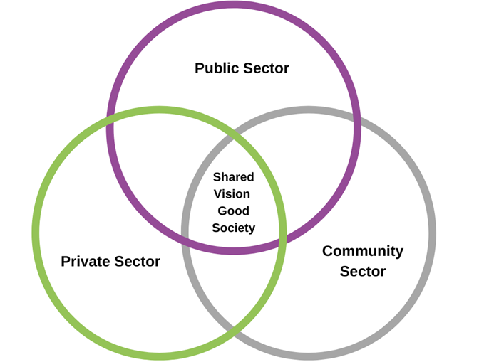

# Power to Change approach

At the heart of this approach is the belief that we need to work with young people in a joined up, agile and holistic way that is rooted in partnership working and a solid understanding of the local place and context. It is also based on the belief that young people are often best placed to know what is best for them and, given support and encouragement, they can become “creators” rather than just “consumers” of services and solutions.

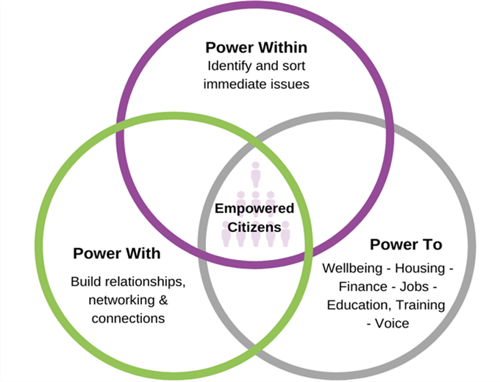

## Power within

Many of the young people we work with are having to deal with a wide range of complex issues. There is no point trying to work with them on issues such as getting a job or sharing their lived experience until this ‘chaos’ is dealt with. Key to our approach is being young person centred and working with the young person to identify the issues they face and to support them to understand why this is and how they might bring about change. Quite often, this is linked to obtaining secure, safe accommodation, getting out of abusive relationships, seeking practical and emotional support, getting on top of finances and developing IT and living skills. It requires our staff to have strong links with the various community and local authority service providers who can provide specialist support.

## Power with

Many of the young people we work with see themselves as worthless and powerless individuals. They are often living isolated lives and feel cut off from society. We believe that if we can bring people with similar experiences together, it can be an empowering experience. When young people are encouraged to think more collectively about the context and environment in which they have been growing up and how that may have shaped them, it can be a transformational experience. Key to this “social action” approach is that anything that has been “socially constructed” can be changed. In many ways, this unfolding process of knowledge and realisation is the bedrock of effective citizenship. It is also based on the belief that to get on in life you need to be able to develop and build relationships, networks and connections. Your group becomes your back up and a source of inspiration and strength. The more you get used to working in groups the easier it becomes to make new connections and, as any manager or would-be employer will tell you, “Teamwork” is an essential life skill.

## Power to

Once young people start to understand more fully the situation they are in and why so many of their peers are in a similar situation, it can be a powerful catalyst for change. So, for example, we have supported young people to educate decision makers and other young people about their experiences and contribute to structural changes in the way services are developed and delivered. This process also enables young people to develop a wide range of soft and hard skills which many then use to secure a job or enter education or training.

Throughout this stage, we are proactively working with young people to create opportunities for them to build understanding and connections with community, business and local authority staff as well as their peer group. This might vary from attending a community project to completing a work placement with a local business or being mentored by a local business volunteer. Not only do these connections offer practical support, but they also provide young people with experience of meeting people who may well be very different to them. From being isolated and cut off, young people become more confident and sociable.

That is why as well as our youth workers, we have community workers, working to strengthen the community sector and to build links between business, community and local authorities.

# Focus of our work

We will continue to broker partnerships between business, schools, community groups, public sector and young people so we are able to:

## Children and Young People

Support young people we work with to cope deal with and overcome the complex and interrelated challenges and issues they face. We anticipate that the next few years will continue to be “tough,” with high levels of poverty across the city and county, continued cuts in services and less funding locally for the community sector. We also anticipate that the upcoming general election may well fuel division between communities, which has the potential to further “ghettoise” neighbourhoods and erode trust and support for local politicians and decision makers. As poverty rises and services reduce, it also makes vulnerable young people, more at risk of being exploited by and recruited into criminal gangs.

We will offer a range of one to one and group interventions that will be delivered across the city and county. We will build on and add to our youth and community partnerships based in local neighbourhoods alongside the city and county wide issue-based work we y deliver. We will continue to partner with schools and link them with business volunteers who can support young people to develop soft and hard employability skills. We will use creative arts as a method to empower young people to identify issues of concern, to find their voice and develop soft and hard skills. We will create more opportunities for business volunteers to support young people and community groups.

We will prioritise working with care experienced, NEET, homeless, SEND and young people involved in or at risk of being involved in the youth justice system. We will also run neighbourhood-based youth work in both the city and county. We will also run a wide range of employability sessions with business partners in schools across the city and county. The emphasis of this work will be framed by our “Power to Change” approach and will:

• Support young people to deal with the many overlapping issues that hold them back in life such as inadequate housing, physical and mental wellbeing, financial management, dependency issues, dysfunctional and abusive relationships.

• Support young people to understand, explore and enter education, employment and training.

• Enable local business community to share skills, knowledge and resources.

• Ensure young people’s lived experience and voice guides the development, delivery and evaluation of our work and feed into relevant local and national policy and practice debates. We would seek to do this in a creative way, using arts-based approaches as appropriate.

Community development

We will build on our strong relationships with public sector and community groups across LLR to ensure our work is firmly anchored in place based local agendas. Our work will:

• Proactively build on the partnerships we have developed with diverse community groups and seek to develop more ways to enable the business community to partner with them to share skills and knowledge.

• Proactively support neighbourhood youth work initiatives, where business, community and public sector work in partnership to support young people especially those who are vulnerable and at risk.

• Through our #PowerToChange partners forum provide a platform where local community groups can come together to share, reflect, learn and influence local policy and decision making.

• Identify and facilitate practical ways the community, business and public sector can work together to strengthen community responses to poverty and exclusions.

• Create more opportunities for the business sector to contribute to local community development.

• Support initiatives that seek to promote understanding between the diverse communities of our city and county.

• Reflect on learning arising from our work and promote partnership working between business, community and public sector through a variety of formats.

Priorities

As we enter 24/25, we have identified the following:

1. **Programme delivery.** We will continue to deliver high quality, high impact, high profile programmes where all our work is planned, monitored and evaluated within a Results Based Management framework. We will ensure all internal and external donor targets, milestones, budget and reporting deadlines are met. We will continue to improve our ability to capture both “hard” and “soft” data arising from our work and create an embedded reflection and learning work culture. We will ensure we share our learning to relevant local, regional and national audiences. We will seek to develop our capacity to use “Arts” based approaches to support young people and community partners finding and sharing their “voice”. We will deliver a high profile #PowerToChange conference in Autumn 2024.
2. **Income.** We will continue to proactively seek sustainable income streams which add value to our vision, mission and values. We are keen to seek and win core funding alongside project funding. This will involve all our programme workers but especially managers becoming more aware of the “funding ecosystem” for their work and being able to highlight opportunities that we might be able to pursue in order to continue and or develop/expand our work. We will support sector managers and Heads of Programmes to develop their fundraising skills. Where it makes sense to do so, we will work with relevant coalitions and partnerships, to win funding as we have done through the Reaching People coalition in a successful UKSPF bid.
3. **Teamwork.** We will aim to work in a creative, agile and joined up manner where all staff are encouraged and supported to proactively participate in the development of our programmes and projects. Managers will proactively seek to ensure all staff are supported and given opportunities to grow and develop in their roles through consistent, ongoing and recorded performance management. We will revisit and amend or create as required systems and structures that enable us to work in a consistent way, where all staff feel valued, safe, and supported.
4. **Business partners.** We will partner with local businesses to develop new opportunities for business volunteers to engage with young people and community groups. This will include remote as well as face to face volunteering. We will explore more ways that business volunteers can mentor young people and community leaders. We will seek to recruit new business members. We will improve how we communicate with the business community so they are better able to understand and support our work.
5. **Mainstreaming issues.** Across all areas of our practice, we will seek to mainstream Diversity and Inclusion and working in an environmentally friendly way.

# Conclusion

It is likely that high levels of poverty will remain across our city and county in the coming year. This in turn will generate a complex web of issues and challenges for young people and communities. Our Power to Change approach has the potential to bring young people, communities, schools, business and public sector together to tackle these issues. Rather than seeing young people and communities as victims or problems, we see them as assets and solutions who can create rather than just consume ideas and policies.

We believe our power to change approach can inspire people to work together and in doing so turn despair into hope, and strategic action for long term change.

#TogetherWeCan

Kieran Breen CEO Leicestershire Cares